NAME : SONI KUMARI AGE: 26 Y/ F DATE: 26 May 2026
Refd. By.: DR. DR. A K SINGH MBBS, UCMS, MS(G. SURGERY), FIAGES, FMAS, USMLE(USA), DNB(I), FICS, EISE, ECGMG(USA), MCh(NEUROSURGERY)
====================================================================

M.R.I. STUDY OF BRAIN
TECHNIQUE: Multiplanar, multisequence Magnetic Resonance Imaging of the brain was performed using a high-field 3.0 Tesla system.

Findings
- Brain Parenchyma: The cerebral hemispheres show normal signal intensity and morphology. There is no evidence of focal solid or cystic lesions. No areas of restricted diffusion are seen to suggest acute infarct. No evidence of intracranial hemorrhage or space-occupying lesions.
- Ventricular System: The lateral, third, and fourth ventricles are normal in size, shape, and position. There is no evidence of midline shift or mass effect.
- Extra-axial Spaces: The basal cisterns, sylvian fissures, and cortical sulci appear normal for the patient's age.
- Brainstem and Cerebellum: The midbrain, pons, and medulla appear normal. The cerebellar hemispheres and vermis show normal signal intensity and foliation.
- Vascular Structures: Major intracranial flow voids are maintained. No obvious vascular malformations are visualized on the routine sequences.
- Sella and Parasellar Regions: The pituitary gland and stalk appear normal. The optic chiasm and cavernous sinuses are unremarkable.
- Orbits: The visualized orbital contents are within normal limits.
- Calvarium: The visualized skull bones show normal signal intensity.

IMPRESSION:
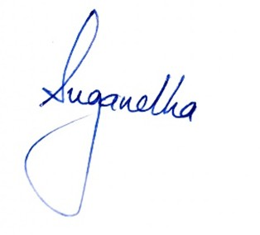
Normal Study of the Brain.

